Separating mixtures
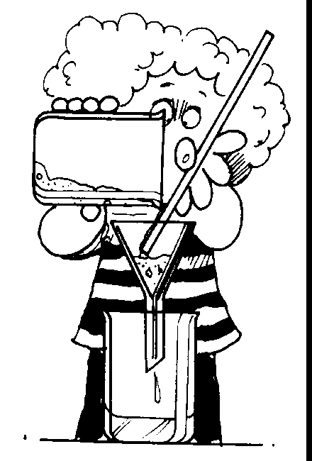
Sedimentation and Decantation
These processes can be used to separate an insoluble solid from a mixture of the solid and water. If the insoluble solid is heavy enough it will settle to the bottom of the vessel (sedimentation ) and form a sediment. The clearer water can then be separated from the solid sediment by pouring the liquid off (decantation)
This process has a disadvantage in that the process of sedimentation can be very slow.

Filtration
Filtration can be used to separate an insoluble solid from a mixture of the solid and water. For example, a mixture of sand and water can be separated by filtration.
In the filtration process, the mixture is poured through a folded filter paper supported in a filter funnel. The liquid passes through the small holes in the filter paper but the solid is trapped on the filter paper. The liquid that passes through the filter paper is called the filtrate and the solid trapped on the paper is called the residue.

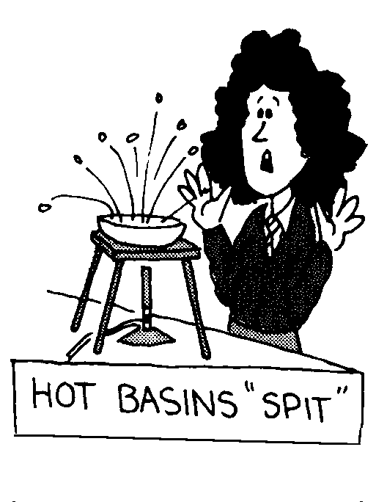

Evaporation
The change of a liquid to a gas (or vapour) is called evaporation. Evaporation can be used to separate a dissolved solid from its solvent. For example, salt can be obtained from sea water by the process of evaporation. In this process, the solvent is evaporated and the solute is left behind in the container.

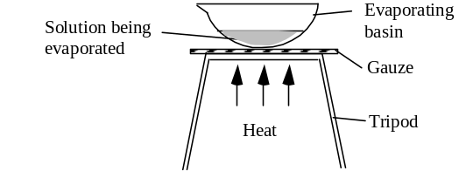
Distillation
Distillation can be used to separate the solvent from a solution. For example, distillation can be used to obtain pure water from sea water. Distillation involves boiling (or vaporising) the solvent and then condensing the vapour to form a liquid. The liquid which condenses is called the distillate.



